How to Recover from Caring Too Much
If you laugh at unfunny jokes, raise your hand too quickly, or can’t decide on your favorite color, you may be exhibiting a fawn response.
By Katy Waldman
January 12, 2026
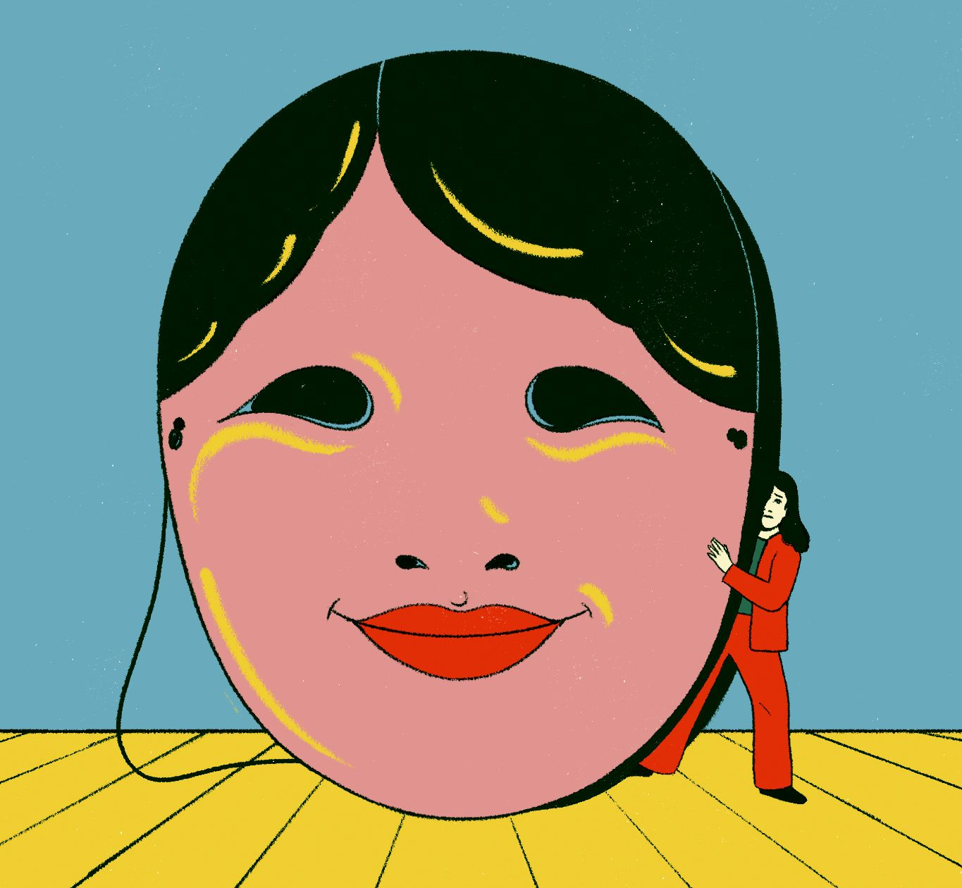
According to the psychotherapist Meg Josephson, fawning is alternately a path to self-annihilation and a “subtle superpower” of heightened perception and sensitivity.
It is the afternoon of the fawn. Everywhere you turn, in workplaces and households alike, yearlings with saucer eyes, brown felt noses, and stilt-like legs are wondering if you’re mad at them. The fawn response, as it’s known in some precincts of social media, bundles various forms of ingratiating, people-pleasing behavior. It can manifest in threatening situations, where expressing authentic emotion could elicit a powerful person’s wrath or cruelty, or it might be more banal: laughing at a vindictive supervisor’s unfunny joke, saying you love a gift when you don’t, laboring over the perfect string of whimsical emojis to append to an opinion that you’ve expressed over text. In a new book, the clinical psychologist Ingrid Clayton recalls hearing about the concept and feeling that she’d found a skeleton key for understanding both her patients’ lives and her own. “It was like I saw fawning everywhere,” she writes. “We were having a collective awakening.”
Clayton is the author of one of two recent books that try to release fawners from their plight. Her contribution, the rhapsodic and quirky “Fawning: Why the Need to Please Makes Us Lose Ourselves—and How to Find Our Way Back” (Putnam), joins the chatty and pragmatic “Are You Mad at Me? How to Stop Focusing on What Others Think and Start Living for You” (Gallery), by the psychotherapist Meg Josephson. Both authors are white women who live in California; both have large followings on Instagram. Josephson’s book originated with a viral video in which she summoned for her audience the reassurances that her younger self would have most liked to hear. “They aren’t secretly mad at you,” she promised. “Your mind is lying to you because it’s scared. I know you may have this fear that you’re secretly a bad person and it’s just a matter of time before everyone finds out, but you’re actually safe.” Within hours, Josephson recounts, the post had blown up across social-media platforms, with hundreds of commenters expressing recognition and relief. “Why am I crying?” one user wrote.
Both authors write as recovering fawners, weaving their own stories through case studies and explication of therapeutic motifs. (They explain that they prefer the term “fawning” to “people-pleasing” or “codependency” because it sounds less judgmental, and because, in their formulation, it addresses the wellspring of the tendency: childhood wounds.) Each one grew up in a home that required her to curry favor with volatile and inconstant parents—a menacing father figure, a recessive and enabling mother—and each found a fragile safety in her caretakers’ occasional good will. The authors were diligent students, high achievers. When they left home, they engaged in self-destructive patterns: Josephson developed a drinking problem; Clayton dated terrible men. “Well into my thirties,” the latter writes, “I joked that I must be wearing a sandwich board that read: users and abusers, please apply here.” As Josephson tells it, fawning is alternately a path to self-annihilation—a “belief that we need to neglect ourselves for the comfort of other people”—and a “subtle superpower” of heightened perception and sensitivity.
The books draw on the work of the psychotherapist Pete Walker, who, in his book “Complex PTSD: From Surviving to Thriving,” from 2013, defined fawning as a trauma response, analogous to fighting, fleeing, or freezing—a way that victims seek safety “by merging with the wishes, needs and demands of others.” The idea reverberates in recent efforts within domestic-violence advocacy to reframe victims’ solicitousness as a survival mechanism. In a 2023 paper co-written with Jaycee Dugard, who was kidnapped as an eleven-year-old and held hostage for nearly two decades, the psychologist Rebecca Bailey argued that a victim’s bond with her captor might be better understood as a “powerful instinctual strategy to survive and thrive.” By some interpretations, the fawner resembles Scheherazade, forestalling death through creative feats that appease the men around her.
In Clayton’s and Josephson’s hands, though, the fawn response becomes something more pliable, less a sign of acute threat than a broadly anxious orientation to the world. “For some people, fawning is about being more of who they are—smart, generous, successful, funny, or beautiful,” Clayton writes. “For others, it’s about being less: vocal, ethnic, creative, self-assured, or able to set boundaries.” Fawning wears various faces: perfectionism, promiscuity, self-deprecation, workaholism, overspending. (“We can’t show up as an authority in our financial lives any more than we can anywhere else,” she adds.) The fawner, scarred by past experiences of rejection, courts not just individuals but people in the aggregate—a monolithic other, dangling validation like a carrot.
A refrain running through the books is that fawners don’t feel real to themselves. While shopping for bath towels for her first apartment in New York, Josephson realizes that she doesn’t know what her favorite color is, and contemplates checking Instagram to see which colors other people like. “Am I even real?” she recalls thinking. “Or am I just a medley of other people’s personalities and preferences?” Clayton and Josephson cast their gazes over the social order, dismayed by constellations of inauthenticity and self-erasure. Some fawners are prone to approval-seeking behaviors, like pursuing prestigious but soul-sucking careers. Others take on last-minute babysitting gigs for friends and feel their pulses quicken when someone calls in distress—reactions that might look, to the untrained eye, like ordinary kindness. Wearied by the myriad inconveniences and injuries that come with other people, the authors wonder whether all this adds up to one big, unacceptable compromise. They look, as Mr. Rogers once instructed, for the helpers. Then they ask them: Wouldn’t you like to be free?
If fawning involves one kind of hypervigilance—“walking on eggshells, being preoccupied with the worst case scenario, not sleeping well, startling easily,” per Clayton—unfawning requires another, in which your every motivation merits inspection, then reinspection. Clayton invites her readers to examine whether they truly wish to give to charity or are simply trying to purge trauma-induced feelings of low self-worth. “We aren’t being generous if it’s at our own expense,” she explains. When a client, whom she calls Lily, a “perpetual babysitter, party thrower, cheerleader,” agrees to watch a friend’s nervous dog, Clayton is incredulous. “Lily, do you even like dogs?” she exclaims. “Would you say yes to such an impossible task if she asked again?”
During the unfawning process, Clayton writes, “we practice not being the first one to volunteer, to offer to pay, to jump in to help, or to rescue another person when things go wrong.” Nor should the recovering fawner be faulted for actions she took in the throes of her anguish. “Lying to ourselves and others in fawning is not a moral indiscretion,” we learn—in part because trauma has overwritten the victim’s relational playbook, instilling reflexes that hurt her at least as much as they hurt you. Narrating how one of her patients feigned a heroin addiction to gain sympathy, Clayton notes that the fabrication was an unconscious response: “She didn’t set out to lie. The lies were involuntary, reflexively spilling out.”

The fawner depends on others to prop up her self-image; the unfawner knows when to discard them entirely. “Fawning enmeshes us with our environment, with the people around us,” Josephson warns. The books, reversing a once ubiquitous pop-cultural injunction to empathy, pick up on an ambient suspicion that we’d all be better off if we could just keep our eyes on No. 1. On social media, we scroll past pastel-hued infographics about securing our own oxygen masks first, past flowery defenses of cancelling plans, past ads for A.I. companions which urge us to find friendship and contentment in enchanted mirrors. In the political sphere—an arena that’s increasingly entangled with social media—figures such as Elon Musk decry empathy as an emasculating plague. Some right-wing Christians, including the pastor Joe Rigney, the author of “The Sin of Empathy,” have wondered if “an excess of compassion” is leading believers astray. The sentiment’s reactionary appeal is obvious: if our softheartedness is to blame for feelings of helplessness or misuse, then the berserk strongmen running roughshod over the world (not to mention their fawning associates) are in the clear.
For Clayton and Josephson, choosing oneself is more of a treatment plan than an act of tyranny. Like so many before them, they conscript the diagnostic form to suggest that disconnection has curative properties. One radical prescription is to sever toxic relationships, as Clayton does with her mother, who allowed Clayton’s stepfather’s predations. The books also model subtler tactics for quieting the fawner’s social impulses. Josephson likes to turn down the volume on the outside world, cocooning her readers in the white noise of affirmation. “You’re not in trouble,” she soothes. Clayton tends to turn people into tropes: her patients are beleaguered heroines, surrounded by ogres. Before meeting her husband, she writes, she dated the same noxious man, “with a different face, over and over.” These constructions evoke the “solitary fantasy systems” that Janet Malcolm argued are fundamental to human relationships—the projections that block us from truly seeing one another. But why not envision the potential beneficiary of a charitable donation, whom Clayton readily sets aside? Or the friend who, contrary to Josephson’s reassurances, really is mad at you? An unfortunate, and perhaps unavoidable, side effect of embracing one’s main-character status is demoting everyone else to—in the words of the Muskian gamers turned tech barons—an N.P.C.
Ironically, the unfawning project would seem to diminish a person’s life rather than expand it. The patients in Clayton’s and Josephson’s books emerge as more rough-grained and specific than the doctrine that contains them: we meet a history teacher who dreams of writing novels but is consumed by bouts of creative self-doubt, a woman who drives around looking for the perfect slice of pie to deliver to a man who hasn’t texted her back. Such human details are treated as illness presentations. The ordinary pleasures and frustrations of interdependence wither under fawning’s pathologizing scaffold. What the theory offers, instead, is a sphere of social and moral exception—it declares our agency extinguished, our desires flattened, and our actions pre-ratified by our singular pain. “All this behavior—the stuff I was proud of, and the stuff I was not—was fueled by a trauma response,” Clayton writes. All of it?
Both authors invoke trauma as the source of their people-pleasing, from Clayton’s yearning to be “picked” to the formation of what Josephson ruefully calls her “chameleon cool-girl vibe.” Yet there’s another, perhaps obvious explanation for such compulsions: being online. Clayton and Josephson are influencers, after all, and the anxiety of the fawner—of feeling unreal, of collapsing into the world’s estimation of you, of mining something deep and internal for the consumption of others—is also the anxiety of social media. In “Alone Together: Why We Expect More from Technology and Less from Each Other,” from 2011, the sociologist Sherry Turkle described how the loose ties of digital life make us feel exposed and precarious, causing us to scrabble for status and other measures of safety. The internet, in other words, turns us all into fawners.
But the concept’s popularity is surely rooted in something deeper. Clayton and Josephson have seized on a prevailing sense of powerlessness: we feel burdened by expectations to perform, and obligated to care for other people, especially in the absence of political and economic protections. A few years ago, fawning behaviors might have been diagnosed as symptoms of the patriarchy, and the fawn identity—delicate, endearing, self-abnegating—attributed to the unempowered woman. But the pop-feminist frame fell short for the same reason that the pop-therapy frame does now: both try to ferry us on individual journeys, rather than rouse us to a sense of common cause. Also, as both books aptly observe, men can fawn, too.
Partway through “Fawning,” Clayton reminds us that “fawners are seeking approval, safety, and connection.” Later, she writes that “we want to be chosen, to feel safe and loved.” It’s easy to see why she and Josephson prescribe a strict regimen of detachment: as long as other people have the power to confer or withhold their love from us, they will always be intolerable. But we, too, can love—and, in the best case, we do so not because it gives us control but because it awakens us to the world as it is. Surveying the healed fawner’s sterile cloister—the lone protagonist, the ghostly supporting cast—I thought of the novelist Iris Murdoch, who argued, in a 1959 essay, that “love is the perception of individuals.” “Love,” she wrote, “is the extremely difficult realisation that something other than oneself is real.” ♦
Published in the print edition of the January 19, 2026, issue, with the headline “It’s Not You, It’s Me.”

