How Kristi Noem and her husband both pursued MAGA beauty ideals
The recently fired homeland security chief became known as ‘ICE Barbie’ for her MAGA-approved heavy makeup and cascading hair while her husband reportedly fetishized hyperfeminine bodies in women and in himself
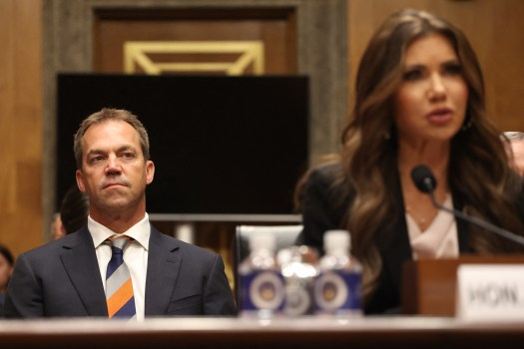
Bryon Noem (L), husband of US Secretary of Homeland Security Kristi Noem (R), listens as Secretary Noem testifies before the Senate Committee on Homeland Security and Governmental Affairs to examine the President’s proposed budget request for fiscal year 2026 for the Department of Homeland Security, on Capitol Hill in Washington, DC, May 20, 2025. (Photo by Alex WROBLEWSKI / AFP) (Photo by ALEX WROBLEWSKI/AFP via Getty Images)

By Martha Ross | Bay Area News Group
PUBLISHED: April 2, 2026 at 2:43 PM PDT | UPDATED: April 3, 2026 at 8:16 AM PDT
Even before Kristi Noem became Donald Trump’s homeland security chief, critics say she began trying to curry favor with the president by becoming transparent about altering her appearance to conform to what’s become known as a recognizable MAGA beauty aesthetic.
That meant wearing cascading hair, heavy make-up, puffed-up lips and undergoing any other surgical enhancements needed to achieve a uniform, ultra-feminine appearance, as cultural critics at Mother Jones, the New York Times and other news outlets have observed.
RELATED: Kristi Noem’s husband secret life possibly outed by undocumented sex worker
At the same time, Noem’s longtime husband Byron was apparently exploring his own obsession with a version of the MAGA beauty aesthetic, but in an extreme, fetishized way that he also appropriated for himself in private settings, according to this week’s bombshell report in the Daily Mail,
During his wife’s controversial leadership of the Department of Homeland Security, Byron Noem, 56, communicated online with female porn performers from the “bimbofication” scene. In describing this corner of the adult-entertainment world, the U.K. tabloid said that participants on fetish sites would transform themselves into “real-life Barbie dolls” by surgically enhancing their breasts to extreme XXL sizes.
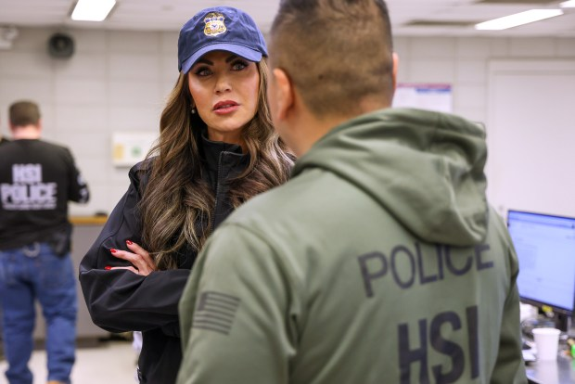NEW YORK CITY - JANUARY 28: In this handout photo provided by U.S. Immigration and Customs Enforcement, the New York City Fugitive Operations Team, joined by DHS Secretary Kristi Noem, conducted targeted enforcement operations resulting in the arrest of an illegal Dominican national on January 28, 2025 in New York City. (Photo by U.S. Immigration and Customs Enforcement via Getty Images)
But Byron Noem took this fetish even further by cross-dressing, the Daily Mail reported. In a selfie that the outwardly straight-laced rancher, insurance executive and grandfather shared with one of these performers, he could be seen squeezing his tall frame into skintight pink shorts and a flesh-colored crop-top, into which he had stuffed two balloons that were supposed to resemble gigantic breasts.
Starting in Trump’s first administration, cultural critics began to observe that the prominent women in his orbit began to adopt a certain look, which encompasses what’s been called “Mar-a-Lago face,” or “conservative girl” makeup. The New York Times chief fashion critic Vanessa Friedman said this look “plays up classically feminine features to an almost cartoonish degree, thus underscoring a retrograde gendered paradigm.”
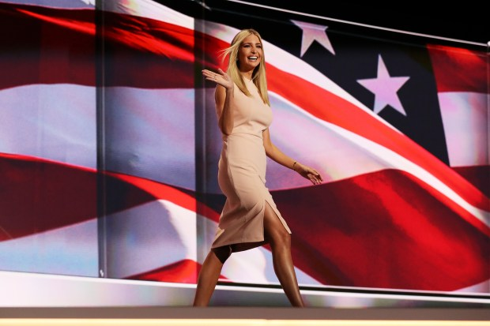Ivanka Trump waves to the crowd as she walks on stage to deliver a speech during the evening session on the fourth day of the Republican National Convention on July 21, 2016 at the Quicken Loans Arena in Cleveland, Ohio. Republican presidential candidate Donald Trump received the number of votes needed to secure the party's nomination. An estimated 50,000 people are expected in Cleveland, including hundreds of protesters and members of the media. The four-day Republican National Convention kicked off on July 18. (Photo by Joe Raedle/Getty Images)
Some of these women also have been likened to Barbie dolls, going back to Barbie-related monikers attached to his his daughter Ivanka Trump. The Barbie reference continued to Noem herself. During her 14-month tenure in the DHS, which ended with her firing last month, Noem was dubbed “ICE Barbie” because of her habit of “playing dress-up” with ultra-feminine looks, the Daily Beast said. Noem liked to put on heavy makeup and apparent hair extensions as she donned uniformed bullet-proof vests and other uniforms while joining in Immigration and Customs Enforcement operations.
For the most part, discussions of MAGA beauty standards have tended to focus on the female face. But these standards also arguably include the “MAGA Mar-a-Lago sexualization” of the female body, as former Trump acolyte Marjorie Taylor Greene described it New York Times in December.
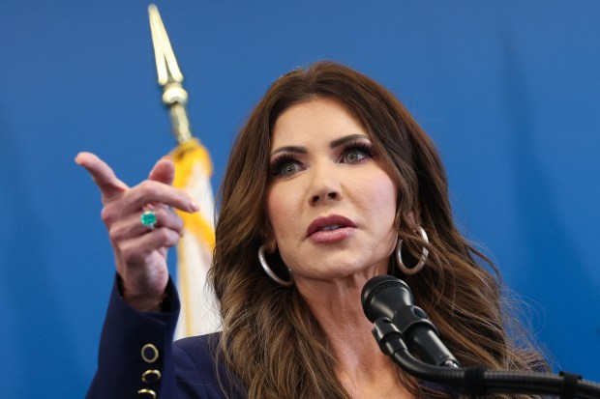US Secretary of Homeland Security Kristi Noem speaks during a press conference to discuss ICE operations in New York City on January 8, 2026. (Photo by TIMOTHY A.CLARY / AFP via Getty Images)
To conform to this physical ideal, women should “puff up their lips,” have nipped-in waists and “enlarge their breasts,” as Greene said, explaining to the Times how she had become uncomfortable with the example it sent to girls like her own daughters. Trump critics also have noted that this ideal no doubt appeals to a president who owned beauty pageants and who was therefore “notoriously obsessed with the literal pageantry of beauty,” as Mother Jones said.
It’s also not hard to see that this body ideal has a lot in common with the traditional Barbie doll, which was known for her exaggerated and unrealistic physical proportions, which historically included long legs, a narrow waist and a perky, ample bust.
In his “secret life,” Byron Noem confessed his lust for “huge, huge ridiculous boobs,” according to the Daily Mail, which said he shared hundreds of messages online with three “bimbofied” performers, whom the Daily Beast also said are known as “fetish cam girls.” “It’s called bimbofication,” one of the performers explained to the Daily Beast. “People who modify their body to look like a doll. The Barbie look.”

